Week 10: Alert System
Name: Swayam Rudrawar

1. Objective:
Develop an alert mechanism for the intelligent light monitoring system that automatically sends cloud-based Telegram notifications whenever a high-intensity light anomaly is detected in real time.

2. Topics Covered:
- Notification protocols
- Cloud-based notifications using Telegram Bot API
- Real-time anomaly alert generation
- Streamlit dashboard integration
- Alert workflow and event logging

3. Software and Tools:
Tool | Purpose
Python | Alert logic and backend
Streamlit | Interactive dashboard
Telegram Bot API | Cloud notification service
Requests | Send HTTP requests
Pandas | Dataset handling
Joblib | Load Decision Tree model
Plotly | Live visualization
VS Code | Development

4. Alert Workflow Documentation:
- Load the trained Decision Tree model and combined dataset.
- Continuously stream Lux values to simulate live sensor readings.
- Predict the light condition (Bright, Dim, Dark).
- Compare Lux value against the user-defined threshold.
- Detect a high-intensity event when Lux exceeds the threshold.
- Trigger the Telegram Bot API to send a notification to the registered chat ID.
- Display alert status in the Streamlit dashboard.
- Record detected events in the Event History table.
- Continue monitoring subsequent samples in real time.

5. Working Alert System Demo:
The developed system successfully integrates Telegram cloud notifications with the intelligent light monitoring dashboard. During monitoring, whenever the Lux value exceeds the configured threshold (2000 Lux), the application immediately sends a Telegram notification containing the reading number, Lux value, predicted light class, and anomaly status. The dashboard simultaneously updates the live graph, event counter, and event history table.

6. Results:
Figure 1. Updated Streamlit Dashboard with Telegram settings
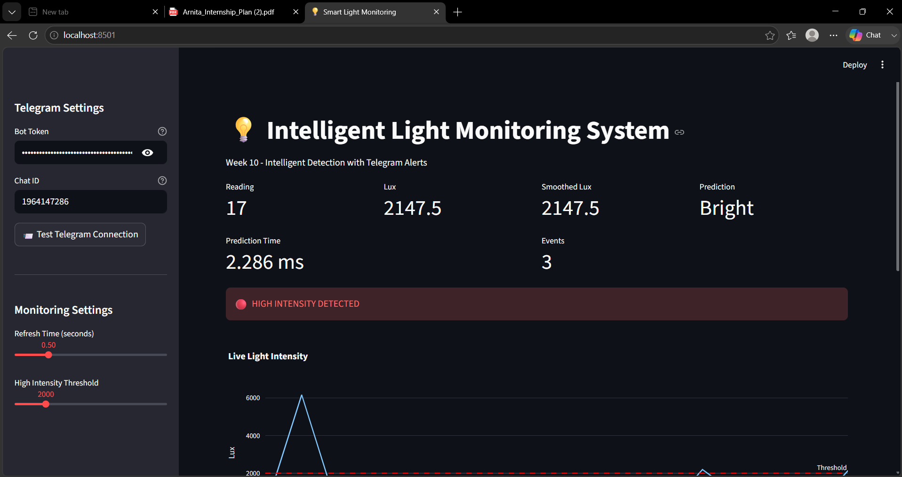
Figure 2. Event History and Alert Status
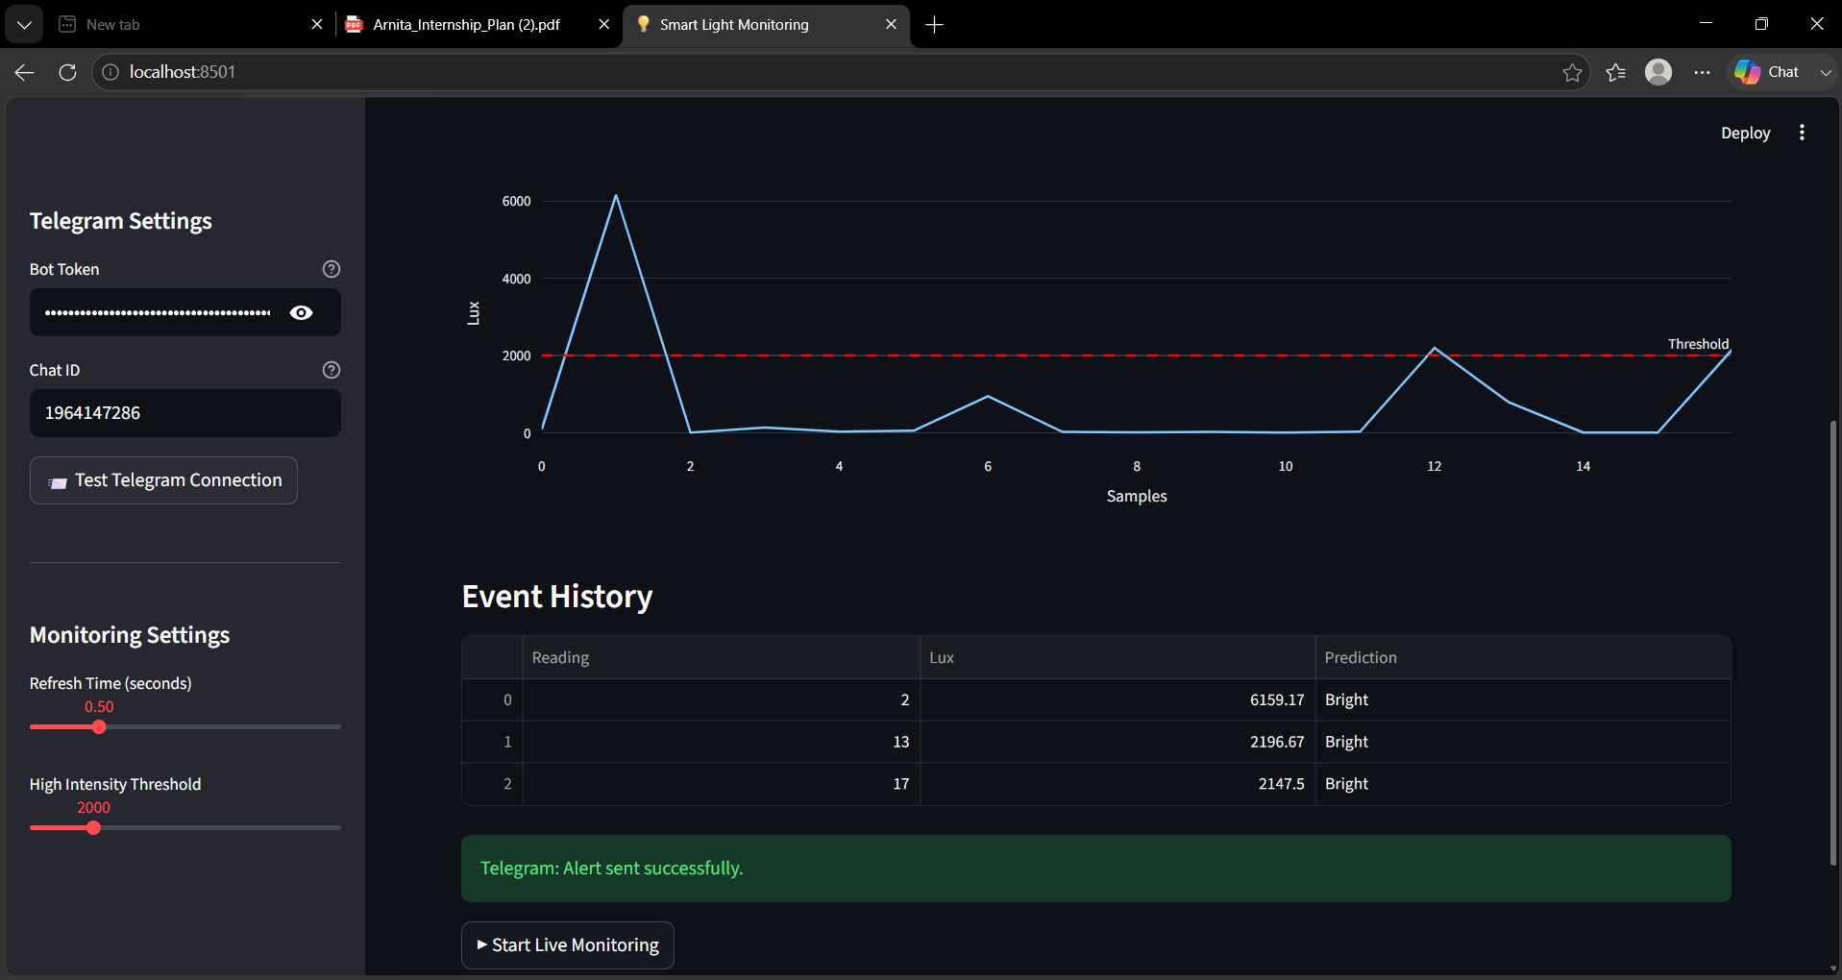

Figure 3. Telegram notification received on the mobile device
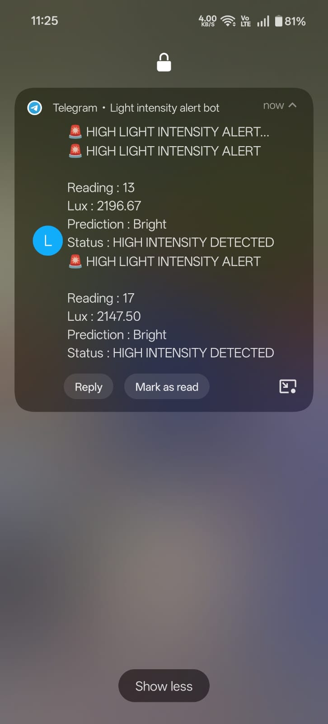

7. Conclusion:
The Week 10 objective was successfully achieved. A cloud-based alert system was integrated into the intelligent light monitoring application using the Telegram Bot API. The system detects high-intensity light anomalies in real time, generates instant notifications, maintains an event history, and provides an interactive dashboard for monitoring. This demonstrates a complete end-to-end alert workflow suitable for IoT and smart monitoring applications.

